# Welcome to the game of craps

## Description of the interfaces

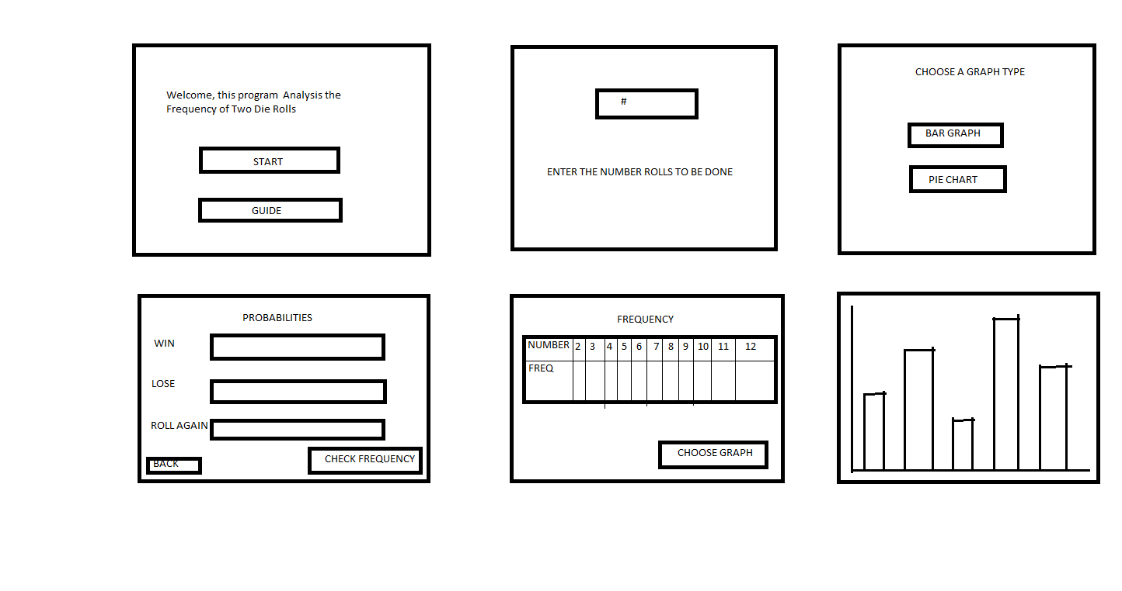

The first Box of the user interface displays two options of which the user is to choose. The start button begins the game and the guide button further explains the algorithm of the game and how it operates.

The second button request the user to input a number or roll a dice, after a display will pop up showing the user if he or she won or lost. Also a roll again button will be below the lose incase the user decides to play again. Below this will be buttons to check frequency and an option to go back to retry. The frequency table depicts options which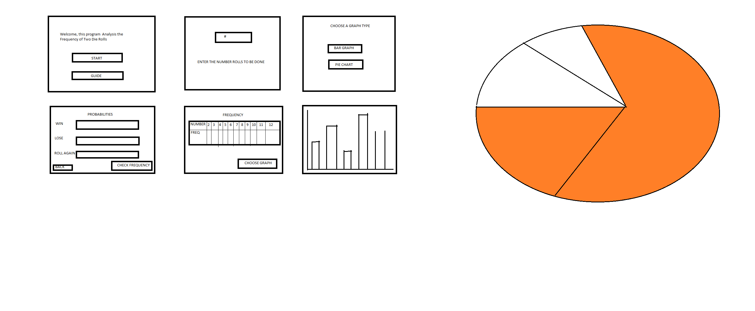which the user will decide which type graph he or she wants, either a Pie chat or a Bar graph.

